VELLORE INSTITUTE OF TECHNOLOGY • SCOPE • ACADEMIC YEAR 2026–2027
REVIEW 1 DELIVERABLES
CreatorOps: Cloud-Native Content Operations Platform
Review 1 Deliverable Report: Problem Statement, Existing System Critique, Proposed System, Requirements, Scope, Use Case Diagram, UI Mockups, & Initial SRS
Course Code & Title  BCSE408L — Cloud Computing & Full Stack App Dev | Candidate Name  Kathyayani T T | Project Title  Project 12: CreatorOps (Marketing SaaS)
Live Deployment URL  https://creatorops-rho.vercel.app | GitHub Repository  https://github.com/ttkathyayani/CreatorOps | Evaluation Review  Review 1 Deliverables

1. Problem Statement
Digital content marketing across multi-channel environments (Instagram, YouTube, TikTok, LinkedIn) requires constant coordination between content creators, agency managers, and brand clients. In current creator operations, creative teams and digital marketing agencies suffer severe operational chaos due to scattered feedback, lack of version control, premature client publishing, and zero structured audit trails.
★ Problem Context & Core Agency Frictions
Operational Pain Points:
• Unorganized Feedback: Revisions sent across WhatsApp, Slack, and email threads lead to confusion over which draft is final.
• Premature Publishing: Creators publish deliverables before brand clients officially sign off on copy and compliance.
• Manual Compliance Checks: Reviewers manually check scripts for forbidden terms, required disclosures, and speaking duration.
• Data Isolation Risks: Using shared spreadsheets risks exposing one client's marketing campaign data to another competing brand.

2. Existing System
In existing marketing agency workflows, content creation, collaboration, and client sign-offs rely on generic consumer tools such as Google Sheets, WhatsApp, Slack, Google Drive, and generic project management boards (Trello/Asana). These tools were never designed for multi-stakeholder creative compliance.
2.1 Existing Workflow Channels & Tools
• Spreadsheets (Google Sheets / Excel): Used for editorial calendars and content matrices. Lacks real-time status locks, cannot preview rich media, has no version diffing, and presents severe data leak risks across clients.
• Messaging Apps (WhatsApp / Slack / Email): Feedback is scattered across unindexed chat threads. Creative suggestions get buried, and proof-of-approval is lost in chat history.
• Generic Project Management Tools (Trello / Asana / ClickUp): Generalized task boards lack creator-specific features such as script duration estimation, forbidden term filters, and dual-tier client gating.
2.2 Comparative Analysis: Existing Tools vs. CreatorOps
Feature / Capability | Spreadsheets & Drive | Generic PM (Trello/Asana) | CreatorOps Cloud Platform
Multi-Tenant Isolation | Manual file permissioning (High Risk) | Workspace-level only; no client barrier | Strict Tenant Workspace Isolation (RBAC)
Content Approval Gates | Informal chat messages ('looks good') | Generic status column ('Done') | Enforced 7-Stage State Machine with Audit Log
Script Analysis & Safety | Manual proofreading by agency staff | None | Automated Hook, Pacing & Brand Safety Checker
Direct Social Publishing | Manual download & manual app upload | None (requires third-party Zapier) | Native Meta Graph, YouTube, & TikTok Publishing
Media Asset Control | Scattered Drive links with expired access | Basic attachment upload | Centralized Object Storage with Presigned URLs
Version Snapshotting | File naming ('video_v2_final_final.mp4') | History log without script diff | Immutable Version History with side-by-side diff

3. Proposed System
CreatorOps is a dedicated, cloud-native Software-as-a-Service (SaaS) web application designed specifically for creator workflows and marketing agencies. The platform enforces 'One Campaign, One Workspace, One Approval Trail'.
1. Multi-Tenant Agency Workspaces: Complete tenant data isolation where agencies manage separate brand clients and creator teams within segregated security boundaries.
2. Programmatic 7-Stage Approval State Machine: Content progresses strictly through Draft -> In Review -> Changes Requested -> Approved -> Client Review -> Ready to Publish -> Published.
3. Automated Script & Content Quality Engine: Real-time analysis of script text for hook placement, speaking duration (130-160 WPM), and forbidden competitor terms.
4. Direct Social Media Publishing: Native API integration with Meta Graph API v19.0 (Instagram), YouTube Data API v3, and TikTok Content Posting API v2 to publish approved content directly.
5. Autonomous Competitor Benchmarking: Automated social ingestion and head-to-head metric benchmarking matrix.
4. Functional Requirements
Requirement ID | Module | Functional Requirement Description | Priority
FR-01 | Authentication | User registration, secure session authentication, and PBKDF2 password hashing. | High
FR-02 | Workspaces | Multi-tenant workspace provisioning with automated slug generation and data isolation. | High
FR-03 | RBAC | Four-tier Role-Based Access Control: Admin, Manager, Creator, and Client. | High
FR-04 | Brand CRM | Client profile management with brand voice guidelines and target audience specs. | Medium
FR-05 | Campaigns | Campaign creation with objective definition, budget tracking, and date scheduling. | High
FR-06 | Content Pipeline | Content deliverable tracking across Instagram, YouTube, TikTok, and LinkedIn. | High
FR-07 | Version History | Automated immutable snapshot creation upon script updates with rollback capability. | High
FR-08 | Two-Tier Approvals | Segregated approval inbox for Manager internal reviews and Client sign-offs. | High
FR-09 | Script Quality Check | Automated script pacing calculation, hook analysis, and forbidden term detection. | High
FR-10 | Direct Publishing | Direct one-click social publishing via Meta Graph, YouTube, and TikTok APIs. | High
FR-11 | Asset Management | Secure cloud media file uploads with file extension and size validation. | Medium
FR-12 | Analytics & Insights | Campaign metrics visualization and public social competitor benchmarking. | Medium

5. Non-Functional Requirements
ID | Dimension | Specification / Metric | Verification Approach
NFR-01 | Security | Tenant data isolation, CSRF protection, PBKDF2 password hashing, RBAC decorators. | Penetration audit & unit test verification
NFR-02 | Performance | P95 API latency < 350ms; sub-second page loads globally via Vercel Edge CDN. | Lighthouse & load testing
NFR-03 | Scalability | Stateless serverless backend architecture; horizontal autoscaling with zero code change. | Vercel edge serverless scaling
NFR-04 | Availability | Target uptime of 99.9% backed by Vercel edge infrastructure and multi-region CDN. | Synthetic uptime monitoring
NFR-05 | Maintainability | Modular Django app structure, PEP8 compliance, automated test suite. | Continuous integration runner
NFR-06 | Usability | Responsive dark-mode UI with high-contrast accessibility across desktop & mobile. | Responsive viewport audits

6. Scope
In-Scope:
• Full lifecycle content operations from drafting to direct multi-platform social publication.
• Four-tier RBAC governing creators, internal managers, clients, and workspace admins.
• Real-time automated script review and brand safety compliance engine.
• Native direct social publishing integration with Meta Graph (Instagram), YouTube Data, and TikTok APIs.
• Cloud deployment on Vercel with automated continuous deployment from GitHub.
Out-of-Scope:
• In-browser multi-track video editing (CreatorOps focuses on scripts, review, compliance, and publishing).
• Direct payment gateway processing for influencer fee payouts.
• Offline desktop client software (platform is exclusively cloud-native web SaaS).
7. Use Case Diagram
The UML Use Case Diagram models the system actors (Content Creator, Agency Manager, Brand Client, Workspace Admin) and their primary interaction boundaries with CreatorOps:
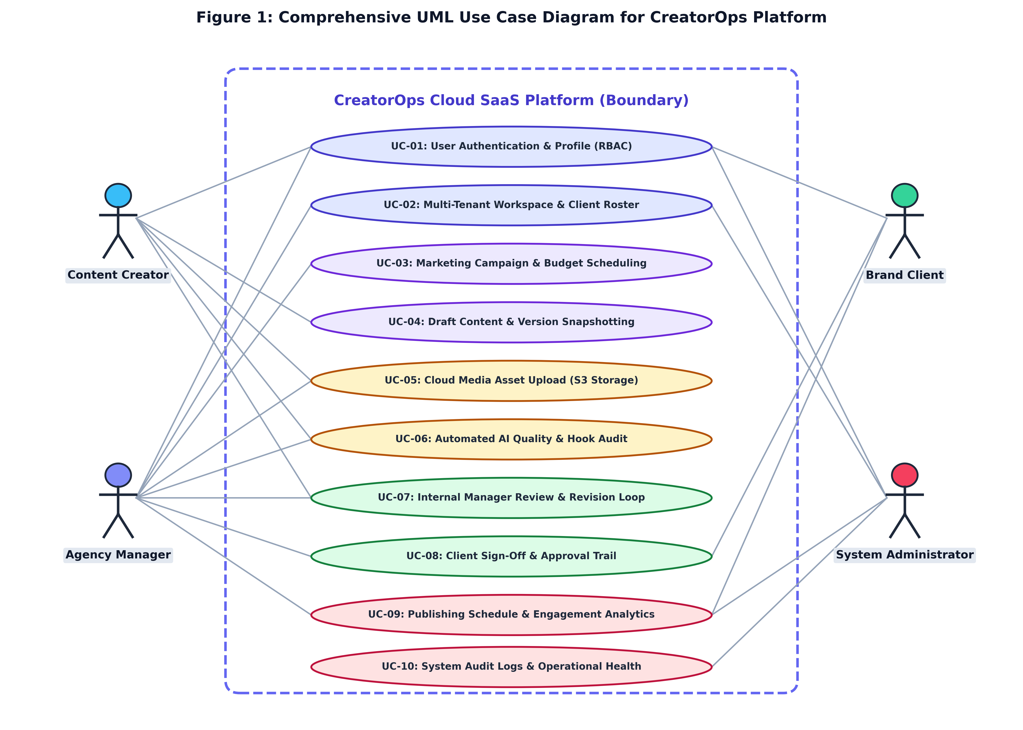
Figure 1: UML Use Case Diagram for CreatorOps SaaS
Actor boundaries and primary interactions: Drafting, Reviewing, Approving, Publishing, and Analytics.
8. UI Mockups
The CreatorOps user interface was designed with a modern, high-contrast dark theme (#0B0F19 canvas, #111827 cards, #FACC15 accent) providing optimal ergonomics for creative operations:
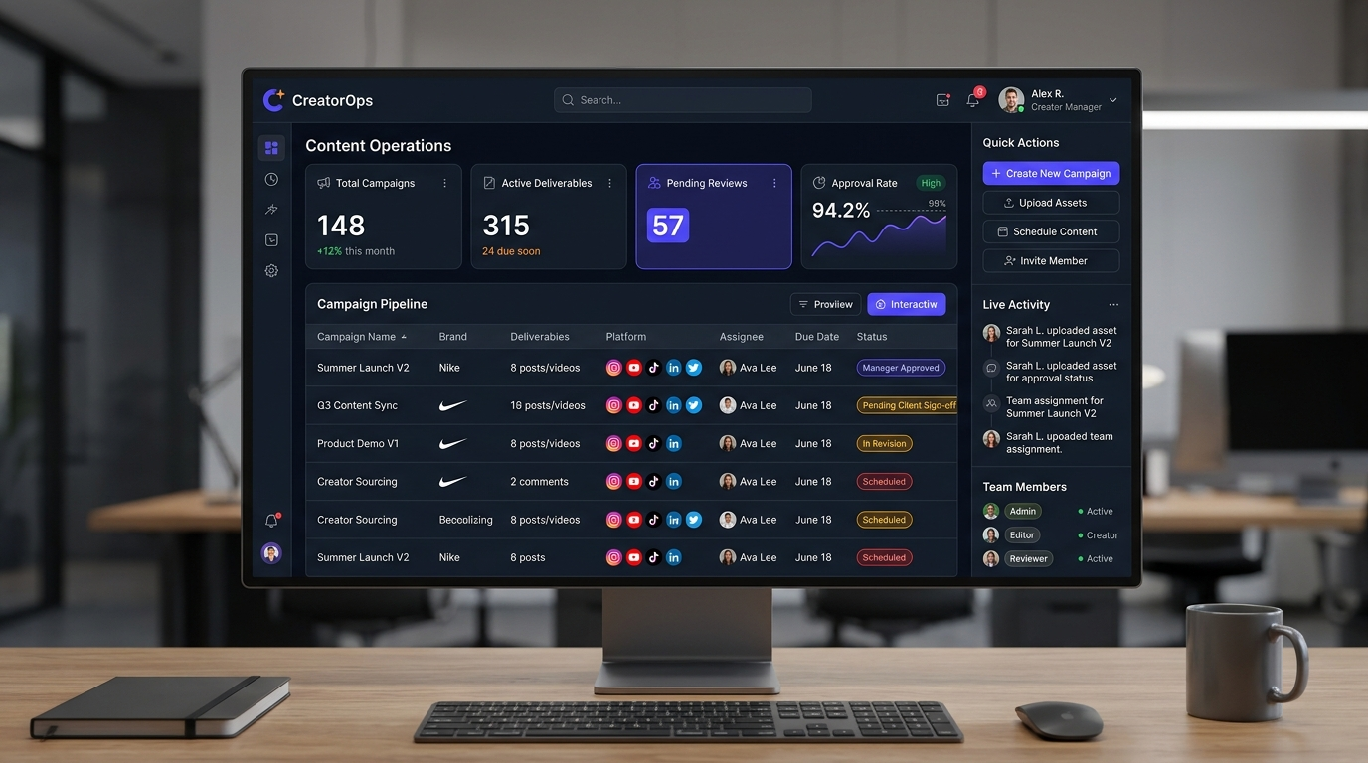
Figure 2: CreatorOps Executive Command Center Dashboard
Unified KPI overview displaying active campaigns, pending approvals, and content velocity.
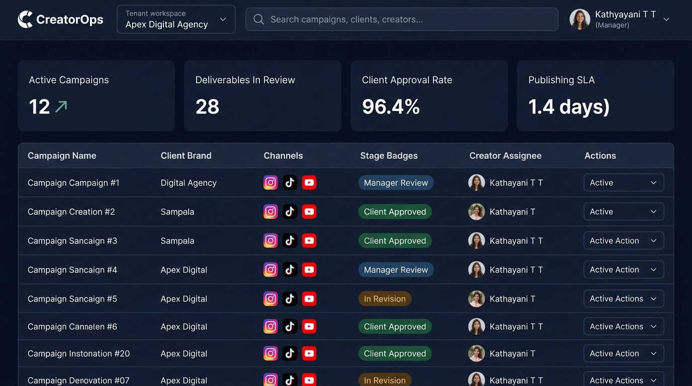
Figure 3: Campaign Content Deliverable Pipeline View
Filterable deliverable matrix tracking channel, status badges, creator assignment, and deadlines.
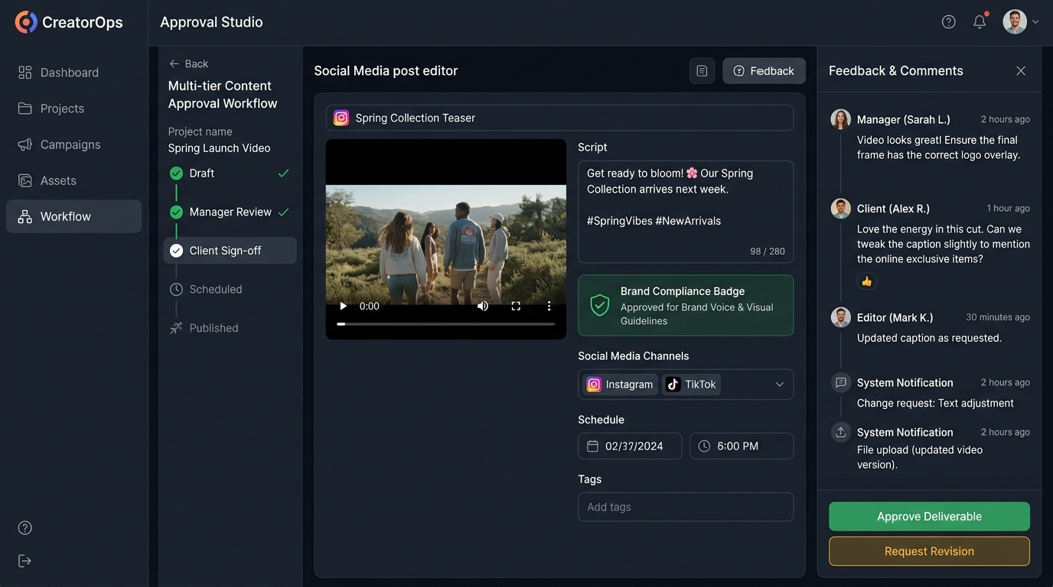
Figure 4: Review & Studio Interface with Direct Social Publishing
Interactive review screen featuring script editor, automated compliance score, version diffing, and direct publishing.
9. Initial SRS (System Requirements Specification)
Summary specification conforming to IEEE 830 standards:
SRS Section | Requirement Specification | Implementation Mapping
1.0 System Purpose | Multi-tenant cloud SaaS platform to eliminate creator marketing workflow chaos. | Core Django SaaS Architecture
2.0 User Classes | Admin (full control), Manager (review/publish), Creator (draft), Client (sign-off). | workspaces.Membership RBAC
3.0 State Progression | Strict 7-stage transition: Draft -> In Review -> Changes Req -> Approved -> Client Review -> Ready -> Published. | content.models.ContentItem state machine
4.0 External Interfaces | Meta Graph API v19.0, YouTube Data API v3, TikTok Content Posting API v2, REST APIs. | content.publishing_service & DRF
5.0 Security & Safety | PBKDF2 password hashing, CSRF tokens, SQL injection prevention, tenant boundary filters. | Django ORM & middleware
6.0 Cloud Infrastructure | Vercel Serverless Edge, WhiteNoise static delivery, managed cloud PostgreSQL. | Vercel serverless edge runtime

